EXPERIMENT NO 17

Determination and plotting of Antenna Gain Calculation. Aim:
To determine and plot Antenna Gain, and calculate the antenna gain in dBi

Software required:
- SCILAB version 6.0.1

Program:
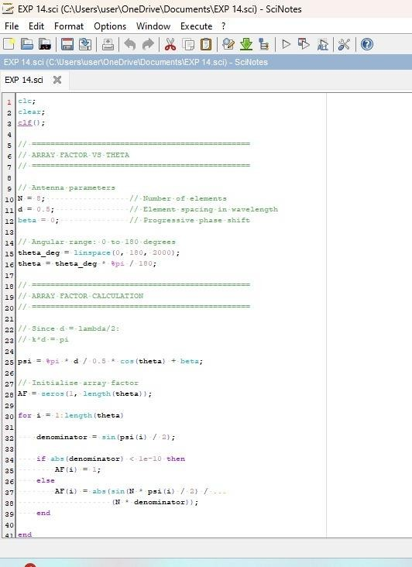

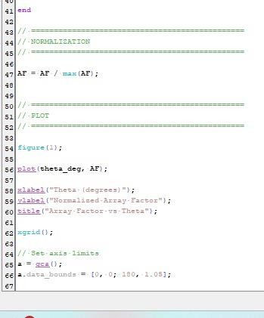

Output:
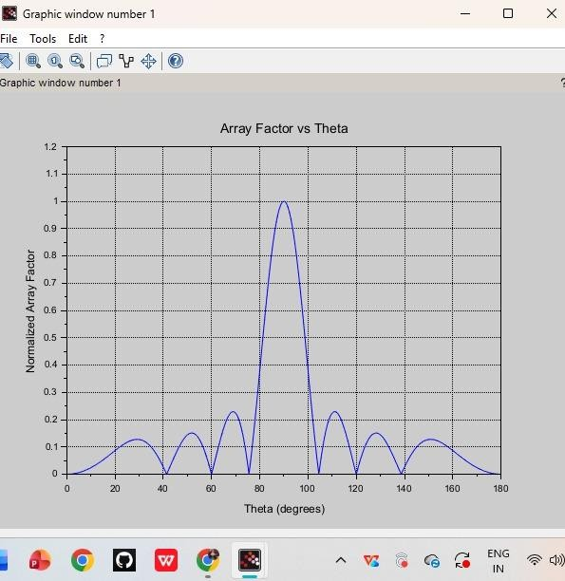

RESULT: The experiment was done and the gain calculation for the given antenna was done. Different case studies were analyzed and the gain was calculated.

